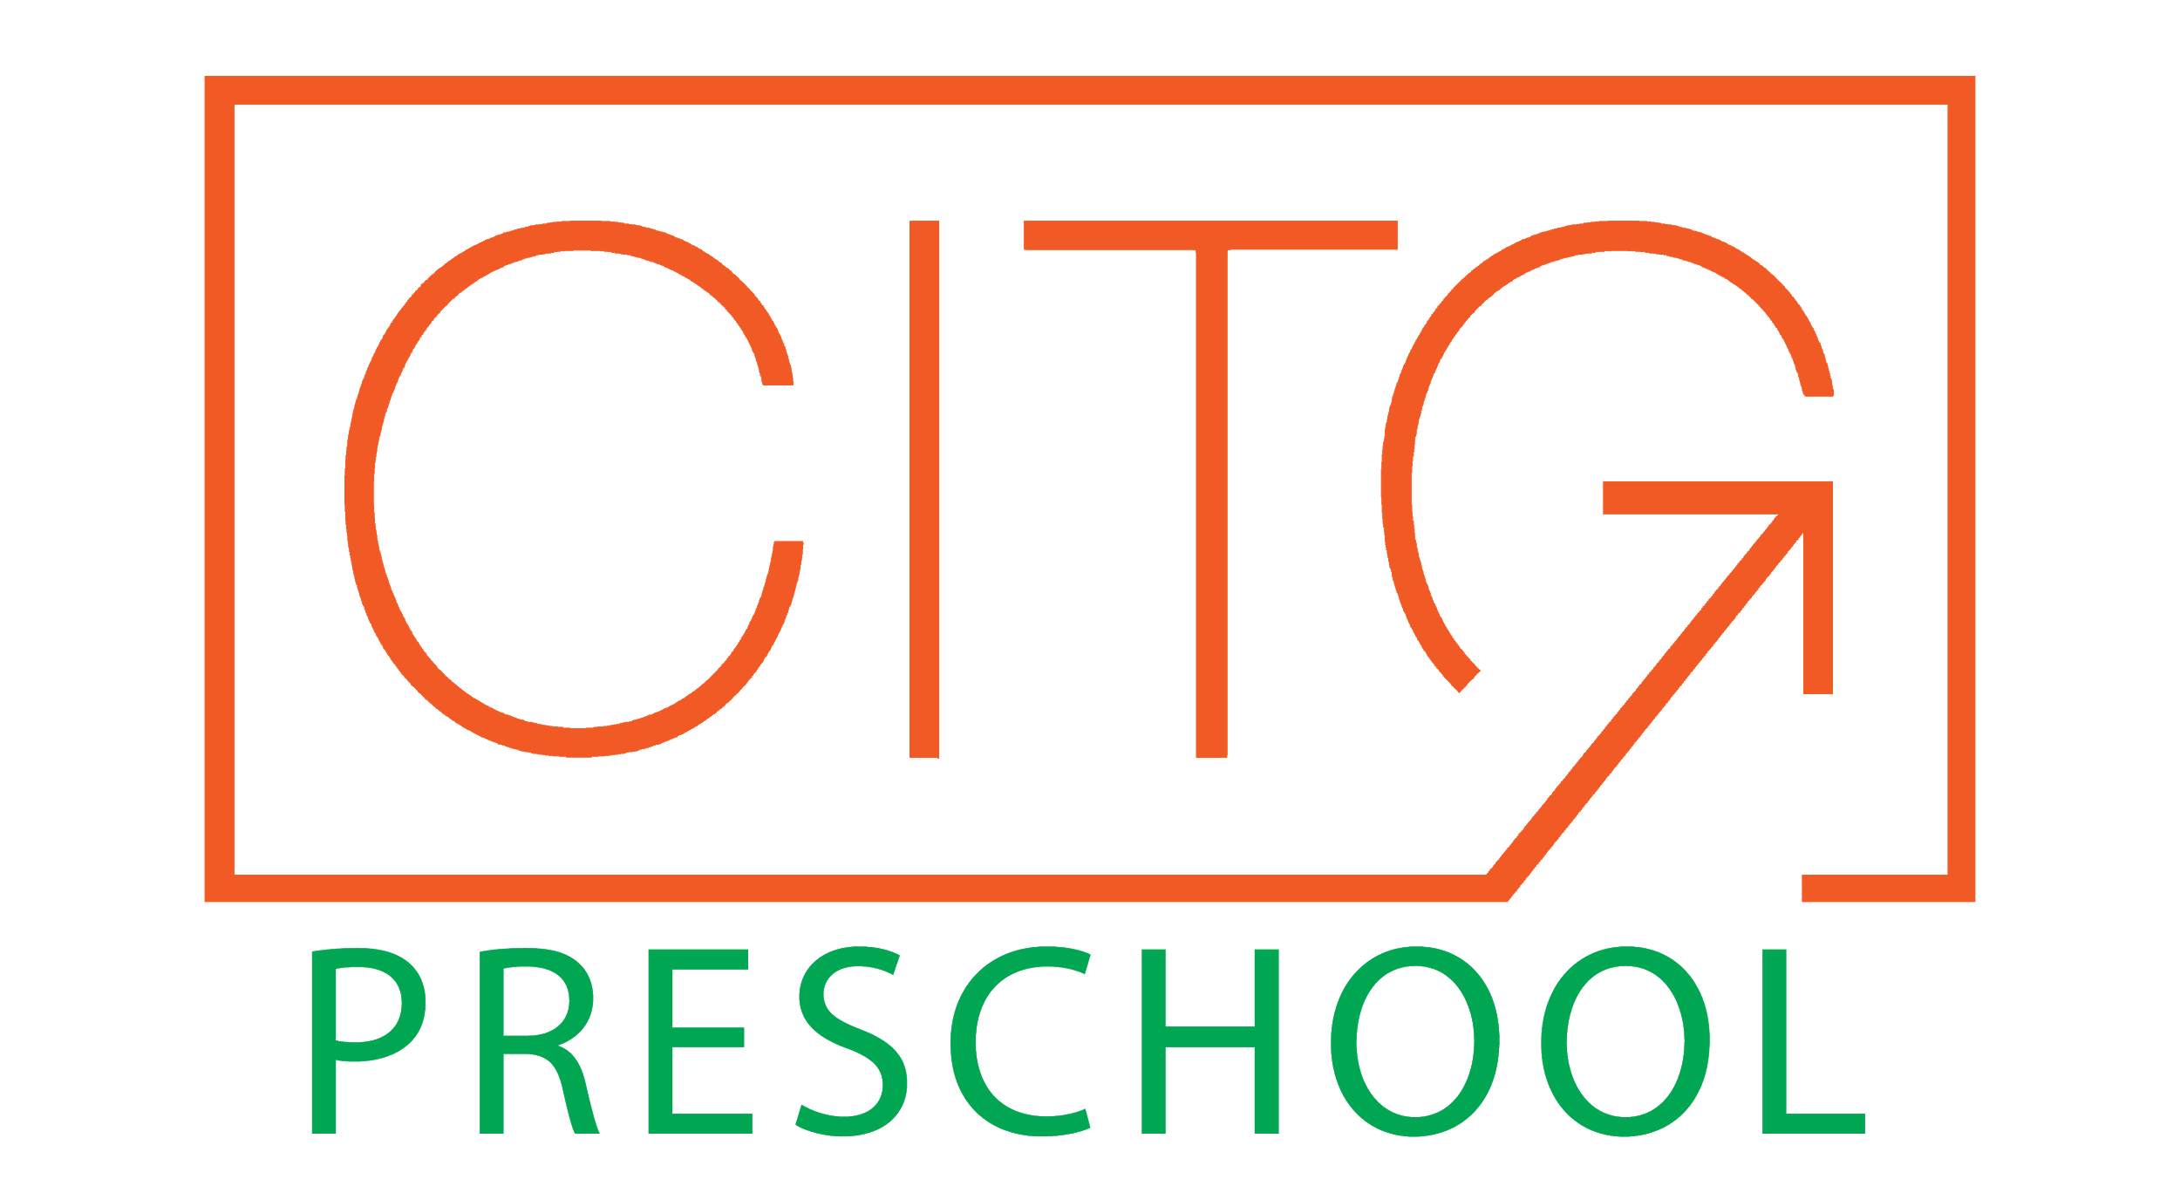
Activities
Chapel 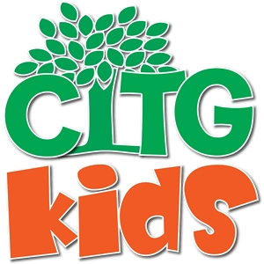
Every Monday at 9:30am, Mrs Shaina, our CITG Kids Ministry
Director, leads all of our students in a time of celebration, worship and spiritual growth. Birthdays that fall within that week are celebrated on stage and parents are welcome to join us whenever possible. We also sing with movement, practice listening, socializing, and comprehension.
Our focal points throughout the year are “God made me,” “God loves me,” and “Jesus wants to be my friend forever.”

Computers
On a weekly basis, our 3 and 4- year-old children will learn basic computer skills with a mouse and keyboard. Using ABC Mouse as a tool, children will be able to participate in activities that will correlate with what they are learning in the classroom.

Brain Dance
Thursdays, modern dancer Kristen Vencel encourages creativity through dance and a story. Brain dance is a full body-brain exercise based on developmental movement patterns that encourage healthy brain development.

Spanish
On Fridays, all of our classes will take part in our new Spanish class through Spanish Academy. This full immersion program will keep your child engaged through songs, activities and participation. The variety of concepts presented will allow your child to communicate in a variety of environments.

Music/Movement
We are excited to have partnered with Patty Shukla, an internationally recognized expert in educational-interactive music for children. With songs ranging in age appropriation, our teachers have been trained to specialize the curriculum to their class. Songs include learning through repetition, movements and sign language. For more information on her curriculum and to watch at home go to pattyshuklakidsmusic.com.

Optional Activities

Rock’n Roll Gym Bus
Fitness on wheels!! The Gymnastic Bus comes to our school every Tuesday and offers 30 minute classes. It helps build your child’s self-confidence while enhancing physical and motor development. For $40 per month you can enroll your child in this weekly fitness experience. For more information, contact Ms. Dawn at (772) 263-6756.

Soccer Shots
Soccer Shots offers a high energy introduction to soccer with a focus on character development. For $45 per month your child will participate in a 30 minute weekly class on Wednesdays. For more information, contact Kennedy at (305)-467-6400 or kennedy@soccershots.org

